Smart Wireless Battery Charging With Charge Monitor Project

The project is a device to transfer power wirelessly instead of using conventional copper cables and current carrying wires and also measure battery charge. It also charges the battery using wireless power transfer concept till it reaches 100% capacity. The concept of wireless power transfer was introduced by Nikolas Tesla. This power is made to be transferred within a small range only for example charging rechargeable batteries etc. For demonstration purposes we have a battery that operates by using wireless power. This requires an electronic circuit for conversion of AC 230V 50Hz to AC 12V, high frequency and this is then fed to a primary coil of an air core transformer.
The secondary coil of the transformer develops 12V high frequency. The system also measures the charge in the battery and charges it until it reaches a 00% capacity. For this purpose we use an Avr family microcontroller that constantly measures battery charges and charges battery automatically until it reaches 100% capacity and stops charging the battery as soon as the charge reaches 100%. Therefore by this way the power gets transferred through primary coil to secondary coil that are separated by certain distance around 4cm. The range may be increased by increasing coil size accordingly. Here the primary coil acts as transmitter and secondary coil receives the power to run a load.
This project can be used to charge batteries of a various devices and applications such as battery charged scooters and vehicles without plugging in as well as measure their charge.

Block Diagram
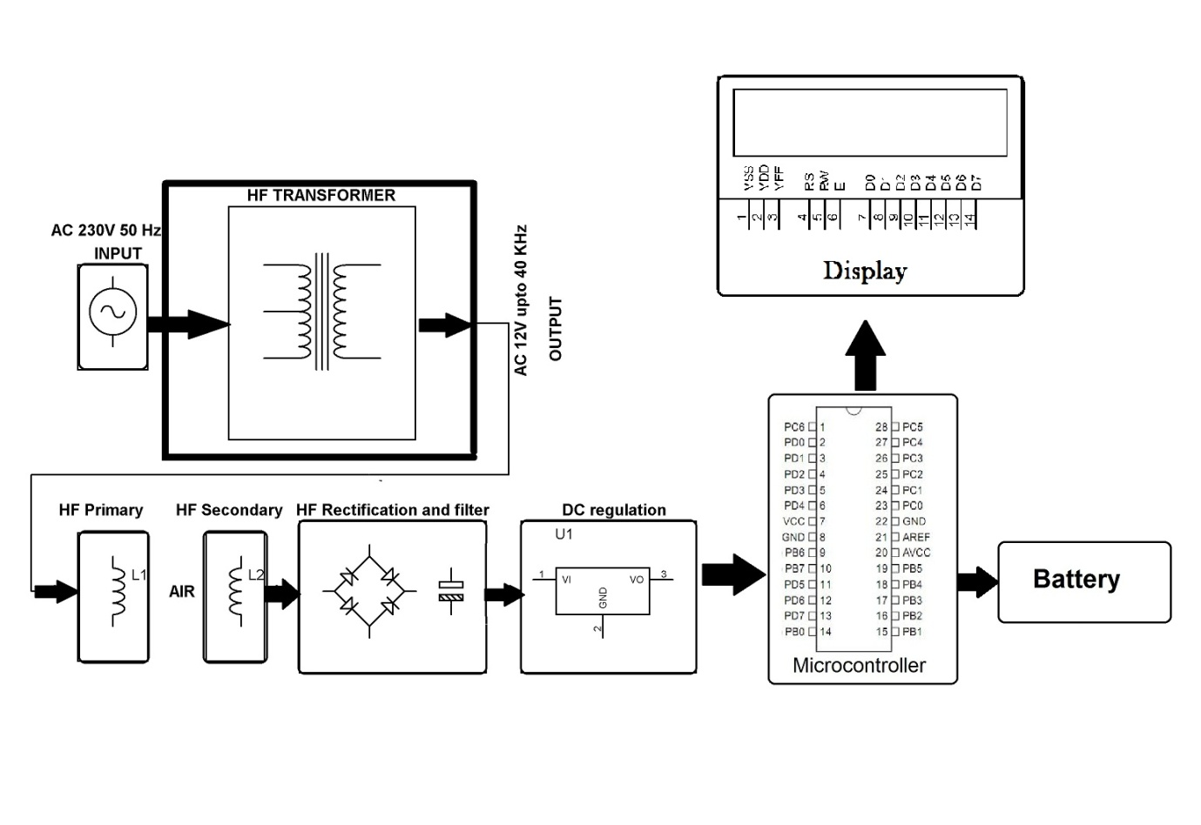
Hardware Specifications

- Atmega Microcontroller
- Transformer
- Regulator
- LCD Display
- Battery 12V

Software Specifications
- Arduino Compiler
- MC Programming Language: C

ATmega328

The Atmel 8-bit AVR RISC-based microcontroller combines 32 KB ISP flash memory with read-while-write capabilities, 1 KB EEPROM, 2 KB SRAM, 23 general purpose I/O lines, 32 general purpose working registers, three flexible timer/counters with compare modes, internal and external interrupts, serial programmable USART, a byte-oriented 2-wire serial interface, SPI serial port, 6-channel 10-bit A/D converter (8-channels in TQFP and QFN/MLF packages), programmable watchdog timer with internal oscillator, and five software selectable power saving modes. The device operates between 1.8-5.5 volts. The device achieves throughputs approaching 1 MIPS per MHz.

Features
- High Performance, Low Power AVR® 8-Bit Microcontroller
– Advanced RISC Architecture
– 131 Powerful Instructions
– Most Single Clock Cycle Execution
– 32 x 8 General Purpose Working Registers
– Fully Static Operation
– Up to 20 MIPS Throughput at 20 MHz
– On-chip 2-cycle Multiplier

- Flash Program Memory: 32 kbytes
- EEPROM Data Memory: 1 kbytes
- SRAM Data Memory: 2 kbytes
- I/O Pins: 23
- Timers: Two 8-bit / One 16-bit
- A/D Converter: 10-bit Six Channel
- PWM: Six Channels
- RTC: Yes with Separate Oscillator
- MSSP: SPI and I²C Master and Slave Support
- USART: Yes
- External Oscillator: up to 20MHz
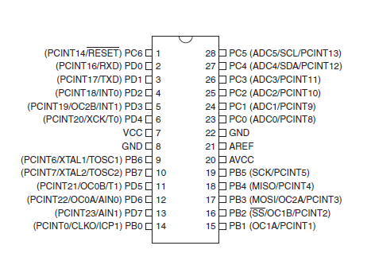

Reference

http://ieeexplore.ieee.org/xpl/articleDetails.jsp?arnumber=7092853&queryText=wireless%20battery%20charging&newsearch=true

http://ieeexplore.ieee.org/xpl/articleDetails.jsp?arnumber=6342402&queryText=wireless%20battery%20charging&newsearch=true

